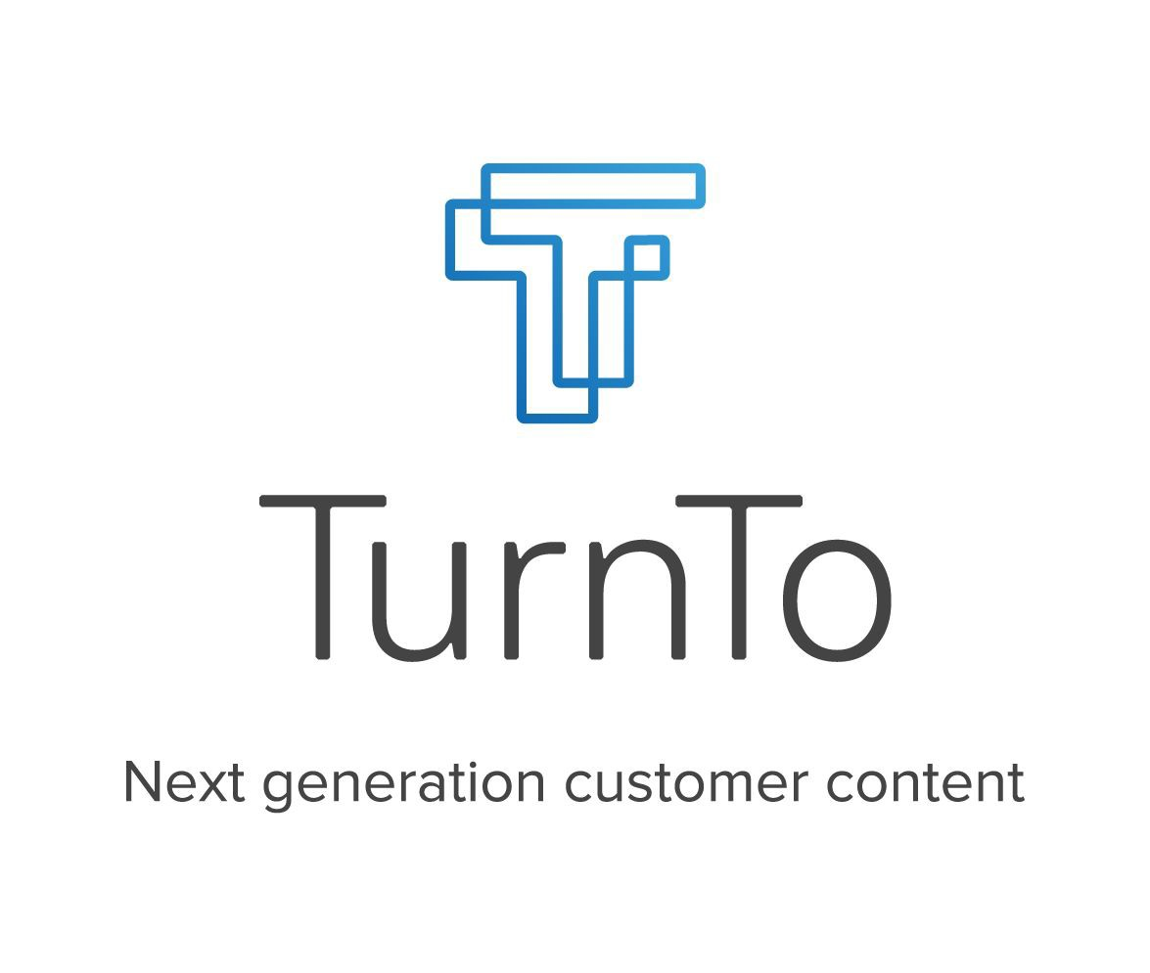

SpeedFlex™ Upgrade Documentation



## Table of Contents

Table of Contents 1

General Notes 3

Upgrading 4

## General Notes

**IMPORTANT NOTE: This document contains the general upgrade instructions for upgrading from a legacy version 4.3 or older to SpeedFlex.**

**If you are not upgrading and this is your first time installing the TurnTo cartridges for your client then please refer to the SpeedFlex implementation guides for either Legacy or SFRA.**

#### SpeedFlex Deprecation List

* Mobile Landing Page
* Geo location feature restriction
* Static embed (all embedding for reviews and Q&A is completed through dynamic embedding)
* Single Sign On (Available in an upcoming version of the cartridge)
* Site Preference Groups (the following groups are deprecated and removed from the meta data)
  + “TurnTo Checkout Comments”
  + “TurnTo Q&A”
  + “TurnTo Reviews”
  + “TurnTo Visual Content”
* TurnTo General Settings site preference group has been modified
* CSS overwrites
* “default” locale (see below for modification around this restriction)

#### SpeedFlexUpgrade List

* All features now live within the TurnTo dashboard
* Dynamic embed so all content matches the TurnTo system
* Star SVGs
* Dynamic Page ID configuration

**Localization**

Those clients using the ‘default’ locale in Salesforce will be required to modify the function “allowedLocales” in HelperUtil.js to use an actual locale code. The TurnTo system does not understand what the ‘default’ locale code means so please write logic to check if the locale is ‘default’ and then replace with another locale that is accepted per TurnTo’s allowed locales.

**Export and Import Jobs**

There have been no changes to the export and import jobs, the only difference is that the reviews and UGC imports cannot be used for embedding content through static embed.

## Upgrading

NOTE: Please note that these instructions were designed from upgrading from a non-modified version 4.3 SFRA site to a non-modifed v5 Speedflex SFRA site. They cannot account for customizations to a client’s site.

1. The SpeedFlex core and/or SFRA cartridges will need to replace the current non- SpeedFlex cartridges in your code base.
2. The SpeedFlex core and/or SFRA cartridges will also need to replace the current non- SpeedFlex cartridges in your sites “effective cartridge path”.
3. Import the latest meta data via the Site Import/Export file “TurnTo_MetaData_Site_v5.zip”.
4. Please verify there are no references to the “default” locale. If there are references, please replace with a valid locale by modifying the function “allowedLocales” in HelperUtil.js to use an actual locale code. The TurnTo system does not understand what the ‘default’ locale code means so please write logic to check if the locale is ‘default’ and then replace with another locale that is accepted per TurnTo’s allowed locales.
5. Remove any references to the mobile landing page in Business Manager, which is through “Pipeline URLs” (Merchant Tools -> SEO -> URL Rules -> Pipeline URLs).
6. Domain names are no longer required, which means you won’t have to change or do anything additional.

Features are enabled / disabled through the widget toggle control panel, and placement is controlled via the installation code.

Pages now have dynamic page IDs, which control certain configurations through added attributes.

Remove all references to single sign on. (Single Sign On will be available in a future version)

**NOTE: If you are having any trouble upgrading, please refer to the legacy or SFRA SpeedFlex implementation guides.**